**SMART GUARDIAN**

Project ID: 19-099

Flood Detection and Security enhancement of Floating devices

Final Report

T.U Mudalige

IT16102842

Bachelor of Science Special (Honors) in Information Technology

Department of Information Technology

Sri Lanka Institute of Information Technology

Sri Lanka

August 2019

**SMART GUARDIAN**

Project ID: 19-099

Flood Detection and Security enhancement of Floating devices

Final Report

(Final Report documentation submitted in partial fulfillment of the requirement for the

Degree of Bachelor Science Special (honors)

In Information Technology)

Bachelor of Science Special (Honors) in Information Technology

Department of Information Technology

Sri Lanka Institute of Information Technology

Sri Lanka

August 2019

**DECLARATION, COPYRIGHT STATEMENT AND THE STATEMENT OF THE SUPERVISOR**

I declare that this is our own work and this proposal does not incorporate without acknowledgement any material previously submitted for a degree or diploma in any other university or Institute of higher learning and to the best of our knowledge and belief it does not contain any material previously published or written by another person except where the acknowledgement is made in the text.

|  |  |  |
| --- | --- | --- |
| Name | Student ID | Signature |
| T.U Mudalige | IT16102842 |  |

The supervisor/s should certify the proposal report with the following declaration

The above candidates are carrying out research for the undergraduate Dissertation under my supervision

Signature of the supervisor: Date:

ACKNOWLEDGMENT

I would prefer to take chance to precise my feeling to any or all of the those who have helped me and provided their support. I would first prefer to impart my supervisor Dr. Pradeep Abeygunawardhana for providing me with this opportunity. you have got provided me with continual support and knowledge, allowing me the liberty to pursue my analysis in the method I assumed best whereas still being there to supply a smart word of recommendation once needed. I cannot many thanks enough for the support and commitment that you simply have shown to me throughout my studies.

To my parents and sister cannot provide thanks enough. you have got forever instilled in me the will to attempt for achievement in my life and have supported me no matter my decisions. you have got been there through each my successes however additional significantly in my failures with unwavering support and for that I will be able to be everlastingly grateful.

I would like to thank my team colleagues Maheshi Gamage, Kavisha dineth and Pasan De silva for them help, discussions and comments in each part of my work. It was a great pleasure working with them.

Most importantly, I owe my greatest thanks to my friend Dinusha Amarathunga and Janith Makawita Liyanage for the encouragement, and wit made this otherwise insurmountable task seem like something I could actually complete.

I am truly humbled and grateful to have so many extraordinary people in my life

Abstract

Internet of Thing (IOT) becomes major momentous element to connect all over the world via the internet. It is more rewarding to improve data collection, data sharing for customer engagement with more flexibility to detect problems or processes. When IoT embedded to our project environment, this concept can be applied incorporated to make it smarter, safer and automated.

‘Smart Guardian’ represent two main IoT devices subsist with sensors and monitoring system.

Flood becomes major negative impact to the humankind and infrastructure. Flood is a natural disaster commonly caused by the run of rivers due to excessively highly rainy season or due to environment effect or global warming effect. Hence, we are addressing flood as the fundamental problem of this project. We are introducing ‘Flood Detect Alerting System’ with IoT and senor technology reinforce us to efficiently evade this impact for humankind.

Flood Alerting system determine the flood occurrence in future through the data collected from the devices. Then, generated alerts are receiving for people acknowledgment via the mobile application. It gathers sufficient time for humans to assemble themselves for impending situation to survive their life and important chattels.

This system monitors all the floating devices; Floating device is an intermediary source to communicate with server through different medium and it is collecting sensor data for flood analysis; to determine the interrupted service or breached devices.

Therefore, through this concept this product is most rewarded for often flood affected nearby areas residents to acknowledge about the impending flood situation to evacuate from their own way to survive without ceasing their life and other properties.

**Table of Contents**

ACKNOWLEDGMENT 4

Abstract 5

1 Introduction 8

1.1. Background & Literature Survey 8

1.1.1. Background 8

1.1.2 Literature Review 10

1.2 Research Gap 12

1.3 Research Problem 13

1.4 Research Objectives 14

1.4.1 Main Objective 14

1.4.2 Sub Objective 14

2 Methodology 15

2.1 Methodology 15

2.1.1 Data Collection 16

2.2 Testing and Implementation 17

2.2.1 Backend Implementation 17

2.2.2 Frontend Implementation 20

3 RESULT AND DISCUSSION 23

3.1 Results 23

3.1.1 Results obtained from SARIMA predictions Algorithms 23

3.1.2 Results obtained from Naïve-Bayes & SARIMA Algorithm 26

3.2 Future Works 27

4 CONCLUSION 27

5 REFERENCES 28

**List Of Figures**

Figure 1.1 Are you a resident of flood prone area? 11

Figure 1.2 Do you think flood prediction is helpful to yourself? 11

Figure 2.1 System Structure 17

Figure 2.2 Backend Implemntation structure 21

Figure 2.3 FrontEnd Interface 01 - Flood Dashboard 22

Figure 2.4 Front End Interface 02 - Flood probability results 22

Figure 2.5 Front End Interface 03 - Floating Device Tracing Dashboard 23

Figure 2.6 Front End Interface 04 - Current data of each attribute comes from floating device 23

Figure 2.7 Front End Interface 05 - View all factors real data 24

Figure 2.8 Front End Interface 06 - View Predicted Flood factors withe real data 24

Figure 3.1 RainFall 7 Days Calibration 25

Figure 3.2 RainFall 15 Days Calibration 26

Figure 3.3 RainFall 30 days Calibration 26

Figure 3.4 Water Depth 7 days Calibration 27

Figure 3.5 Water Depth 15 days Calibration 27

Figure 3.6 Water Depth 30 days Calibration 28

Figure 3.7 Flood Prediction results in percentage 29

**List Of Tables**

Table 1 Feature Comparison 12

Table 2 Collected Data Set 17

# **Introduction**

## Background & Literature Survey

### **Background**

Natural disaster is a detrimental circumstance occurred due to natural process of earth or other geological processes. Natural disaster can be affect to millions of people all around the world that cause to lose of human life or damage property. We were specifically contemplate about accidents as our project to make our project valuable for the humankind to reduce risk from the accidents. Therefore, we have gone through the several incidents that has a possibility to cause human life in danger such as car accidents, natural adversity, drowning and gas leak injuries etc. Then, we were ascertain that due to the water several causes could happen to human with life or economically. As a team, we have focused on drowning and flooding accidents as our research problem to mitigate the human risk due to those accidents.

Flood is aging natural disaster that any humankind could not refrain. Flooding may result due to the body of water in river or lake by increasing the volume. According to the seasonal changes in perception, strong winds, heavy rain and other geological fact, volume of the water in aquatic environment of river or lake can be changed. It would be a result to overflow the water area into the land. In Sri Lanka flood is the mostly affected natural disaster for people. Recent fact for this is heavy strong winds and heavy rain caused over the Bay of Bengal. According to the Ministry of Disaster Management in Sri Lanka approximately 35 deaths , over 700 buildings were utterly destroyed and over 85000 peoples were evacuated from flooded prone areas reported between May 11th 2018 to January 2nd 2019.

Therefore by considering all those facts we come up with ‘Smart Guardian’ to detect the flood prediction for the residents in flood prone area to evacuate before confront to impending flood situation. We were surveyed how could be this Flood Prediction Alerting System convenient for the human kind.

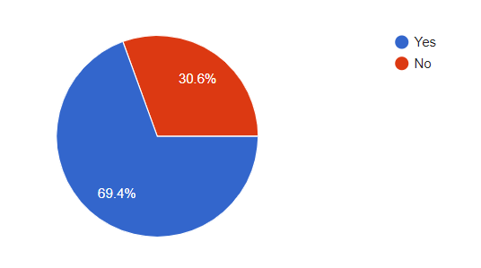

Figure 1.1 Are you a resident of flood prone area?

Out of 96 responses 69.4% people have submitted that they are resident of flooded prone area. Bay of Bengal caused Extreme rainfall and strong windstorm for the North Province, Western Province and Sabargamuwa Province that leads for the flash flood of river and lakes.

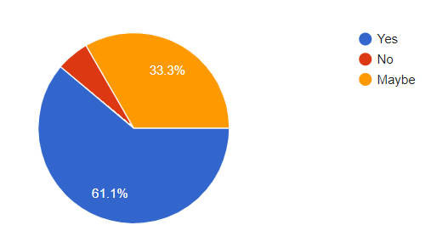

Figure 1.2 Do you think flood prediction is helpful to yourself?

Out of all responses 61.1% people submitted that flood prediction is helpful for them. Person can evacuate the flood affected area when person has time by implying the threating situation that could be happen in near future.

By referring all those charts analyzed from survey, the prerequisite of a Flood Detection Alerting System of SmartGuardian with novel features has been clearly proved. Hence as a team, we were decide to develop Flood Detection system as segment of our final research.

This report provides and further characterization on the function with related work, methodology, testing and result discussion. Features and processes of achieving the goals are well described within the content of this report. Extended details can be searched by referring the references.

### **Literature Review**

Internet of things dramatically improves our world in many ways. Higher output and increased productivity have been two of the biggest reasons in justifying the use of IOT. It has used in many studies of various research. Therefore, many analysis papers and articles were hinge on associated with our analysis product. Despite the fact that most of the options are completely different whereas comparison with the projected product, much vital data is gathered through those papers because the main focus is the same. With the advancement of the technology in IT industry, some people have focused their consideration on ‘Flood Detection Analysis system’ concept. Therefore, several similar product can be found.

We first reviewed Advance Flood Detection and Notification System based on Sensor Technology and Machine Learning Algorithm was developed by Mohammed Khalaf, Abir Jaafar Hussain, Dhiya Al-Jumeily in 2014 [1]. This basically flood detection system designed for immediate notification to the native authorities. It determined the present water level victimisation sensing element network, that provides notification via SMS and internet base public network such Facebook and Twitters through GSM electronic equipment. SMS and internet base public network area unit valuable alert communication tools, which will distribute the knowledge to the floods victims among specific space. Four machine-learning algorithms were utilized to classify flood knowledge. For our project, we applied some of the features such as GSM module , PS module to track the location etc.

Another research reviewed SMS Flood Alerting System in Flood Affected Area was developed by Kirti Bhausaheb Gavali in 2015[2]. It proposed a system that can early warn about the upcoming flash floods for the upstream and downstream areas. It used solar cells as the main power then transmitter the data via the SMS by analysing the water level data. It support us to apply some of the feature for our project GSM module and other relatable modules.

SYN Flood Detection Algorithms has been produced by Matt Beaumont-Gay [3]. He implemented three SYN flood detection algorithms such as SynFinDiff, SynRate, and PCF.SynFinDiff has good detection speed but takes a very long time to return to a non-alert state. SynRate is significantly and negatively affected by attacks that create high variance in the traffic rate, but is faster than SynFinDiff at signalling the end of an attack and PCF performs very well with regards to both detection time and quiescence time. In our proposed product, developing flood detection algorithm by using some of the features.

The Implementation of an IoT-Based Flood Alert System developed by the Wahidah Md. Shah , F. Arif , A.A. Shahrin and Aslinda Hassan in 2018.[4] It proposed the a flood warning system that can detect the water level and measure the speed of the rise of water level. To give the society an earlier notification to evacuate before the water rises to the dangerous level, the measurement result is sent as the alert to a mobile phone through Short Message Service (SMS).

The information which is gathered through these research papers will be lead us to a greater product which will have the ability to serve human in more effective manner.

## Research Gap

|  |  |  |
| --- | --- | --- |
| **Product** | **Features** | **Novelty Features of Proposed Project** |
| Advance Flood Detection and Notification System based on Sensor Technology and Machine Learning Algorithm (2015) | * Consider about the three water flow sensor to predict flood * Used GSM module to send instant SMS about warning alert * Users will receive the alerts via SMS and social networks. | * Consider about three conditions for flood prediction * Separate Mobile application used for send notification. |
| SMS Flood Alerting System in Flood Affected Area | * used solar cells as the main power * Transmitter the data via the SMS | * Mobile application used for flood alerts notify. |
| SYN Flood Detection Algorithms | * Implemented three SYN flood detection algorithms such as SynFinDiff, SynRate, and PCF | * We used machine learning algorithms of ARIMA model for flood prediction. |
| The Implementation of an IoT-Based Flood Alert System (2018) | * Estimate the depth of water and water flow speed for flood prediction * Use SMS to send notification | * We are estimating the depth of water, water flow speed and rainfall condition to predict the flood. * User can notify the alerts via the mobile application. |

Table 1 Feature Comparison

## Research Problem

The ‘SmartGuardian’ has several important functions included to run the process. This product is hinge on two main scenarios. Those are Drown prevention and Flood prediction scenarios. Therefore, overall The ‘Smart Guardian’ product concept mainly focused on few problems. There are,

* How to prevent person from drowning?
* How to know the depth of water where person stands at water?
* How to do the underwater communication to transmit data to server?
* How to locate the affected person?
* How to predict the flood?
* How to identify the interrupted service in devices?

However, in this report we are only focused on the Flood prediction scenario to describe. When comes to the ‘Flood Prediction Alerting System’ segment, to predict the flood it is depend on several parameter such rainfall, depth of water and stream flow speed. To estimate the flood occurrence in near future we need to increase the accuracy of collected data via the floating devices. While achieving above mentioned goals, several research problems were identified. Those are,

* How to come up with an algorithm, which will have the prediction goals by considering the parameters?
* How to increase the accuracy of the prediction via the algorithm parameters?
* How to eliminate the annoying alerts and data received from devices?
* How to estimate the best-case scenario level for alert?
* How to determine the flooded area?
* How to identify the service down floating devices?

To overcome above issues, several information and details are gathered through so many resources like internet, research papers, articles and etc. As well, in the developing process, many numbers of sensors have to be used and we have to develop this project in most feasible manner.

## Research Objectives

### **Main Objective**

The main objective of this ‘Flood Prediction’ function is to evacuate the people from the flooded area before confront to impending flooded situation. From this module we are try to gather sufficient time for the people to prepare themselves to survive. Hence, we want to reduce the no of deaths due to flood.

### **Sub Objective**

There are sub objective under flood prediction module,

* User can know the weather level in any area where the river or lake exist.
* Admins can determine the interrupted service of floating device to fix.
* User can determine through the statistic if user are can be affected or not.

# **Methodology**

## Methodology

Flood is aging natural disaster that every human kinds know. It mainly caused due to heavy perception, strong windstorm and other changing geological conditions. Therefore, any of the human kind could not stop to happen flood or could not escape from it. Because it hinge on natural conditions which caused for excessive rain and ruptured dam to overwhelm a river and spread it over a landscape. Through this product, we are able to predict flood for human acknowledgment. We cannot stop the flood but we are able to notify the residents whoever diggings in flood prone areas. We cannot save the resident’s home but we are expecting to through this product to save human lives. To process this task we need past and current data for prediction. Here is the basic structure of this flood alerting system

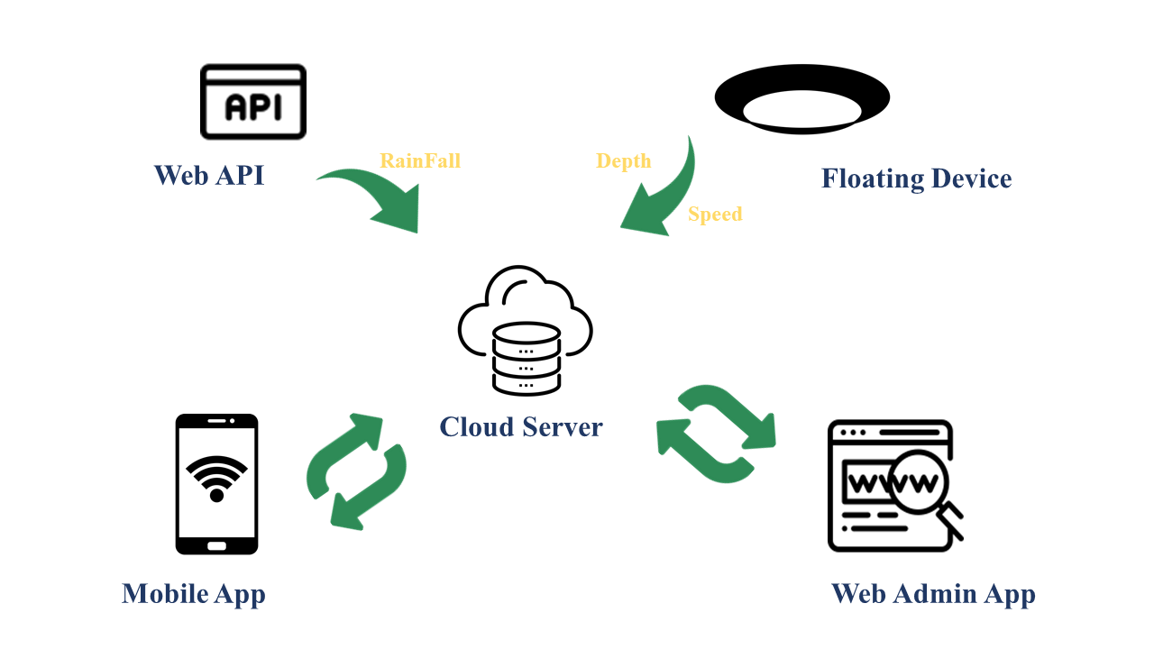

Figure 2.1 System Structure

### **Data Collection**

We can achieve this task via the data received from floating devices. Floating devices is an intermediary source for the communication between under water and server and it is float on river or lake at fixed place. This device has a sensors to collect data according to change of river situation to predict the flood. Those are,

* Depth of water: Ultrasonic Sonar sensor has ability to measure the depth of water where the floating device is fixed on river. It is an instrument that measures the distance to an object using ultrasonic sound waves. Ultra sonic sensor is reliably implemented for the feature of water level sensing
* Rainfall: To measure the perception we are using API from a website. It measures rainfall intensity by operating as a switch when raindrop falls.
* Streamflow Speed: Water flow sensor is used to measure the speed of water flow. When the water flows through the rolls, it speed change according different rate of flow. The half effect sensor output the pulse signal to determine the speed.
* Location: GSM Module support to locate the floating device to determine the device location and flood area location

To train and evaluate the proposed predication platform we need historical statistics of aforementioned data in every Sri Lanka Rivers. However, as the first step, we decided to carry out our case study at Kelaniya area. We collected statistics related to weather of these areas from different sources. All the data sets include data of year 2016 to 2019. Area wise rainfall and water level of Kelani River were collected from Metrological Department of Kelaniya, Sri Lanka.

|  |  |  |
| --- | --- | --- |
| Date | Kelaniya | |
| RainFall | WaterDepth |
| 1/1/2017 | 2.2 | 2.4 |
| 1/2/2017 | 0 | 2.15 |
| 1/3/2017 | 0 | 2.11 |
| 1/4/2017 | 1.8 | 2.11 |
| 1/5/2017 | 2.2 | 2.22 |
| 1/6/2017 | 2 | 2.28 |
| 1/7/2017 | 2.6 | 2.28 |
| 1/8/2017 | 2.1 | 2.32 |
| 1/9/2017 | 0 | 2.22 |
| 1/10/2017 | 0 | 2.11 |

Table 2 Collected Data Set

## Testing and Implementation

### **Backend Implementation**

Prediction of flood is depend on the data of past and current value of aforementioned parameters. Through past data we analyzed the pattern by testing the past data. In this scenario we are using time series analysis methods because the flood prediction is based on realistic time situations that person can become acquainted with the sufficient time for preparation. Therefore we used Seasonal ARIMA model to analyze the past data and provide the prediction value. This model is capable of modeling a wide range of seasonal data and identify the best model that fit for flood prediction pattern with higher accuracy levels and also it is used to get a feel for the intricacies involved in smoothing, de-seasoning, de-trending, de-noising, and forecasting

We started the process with a data set, which reports the rain on each season for last 3 years at Kelaniya, Sri Lanka. The data included the date, and the factors that affects for the flood.

The list of raw data as follows for each row,

**1. Date**

**2. Rainfall:** average rainfall of each date take from the web api

**3. Water depth:** average river depth of each date taken from respective floating device

**4. Stream flow speed:** average river stream flow speed of each date taken from respective floating device

When preparing the data set, initially we used the date as an index in pandas (the python library used for the data analysis) then all the null values in data was marked as “0”. We dropped all the fields that are not important for our prediction.

Notation of SARIMA model,

**Seasonal Arima Model (p, d, q) × (P, D, Q)m**

In here p=non-seasonal Auto Regressive(AR) order , d= non-seasonal differencing, q= non-seasonal Moving Average (MA)order, P= Seasonal AR Order, D= Seasonal Differencing, Q= Seasonal MA order m= repeating seasonal patter time span

This model depend on the seasonal time series. This can be yearly, quarterly, monthly, weekly, daily etc. based on this case study we are focusing on monthly time series pattern for forecasting. It determine the regular pattern of changes that repeat over respective time period. ARIMA model is a liner regression model that it uses its own lags as their own predictors.

Next step is to determine the value of p, d, q, which represent non-seasonal part of the data and P, D, Q, which represent the seasonal part of the data. This is done by using Gridsearch to find the most optimum parameters to use in our SARIMAX Mode. then make the model fit. When there is a stationary value on the data set only the SARIMA model give the results. values will be passed to forward without comparing. The error rate of algorithm for the data set will be calculated by getting predicted value for current existing values using past days. Lowest average error rate is going to selected as best fit value .Once it’s fitted we try to predict the number of observations to the future by calling the predict function. We applied this model for flood factors, which are rainfall, water depth and water flow speed predictions. Because flood is a qualitative measurement. By applying SARIMA into Flood factors we can covey that output of the flood prediction have higher reliability.

Before directly applying this model to the flood prediction to enhance the accuracy, we use Naïve-Bayes Algorithm. It is an intelligent method that uses the probability of each factors to make a prediction.

**Bayes Theorem,**

**P(A|B) = P(B|A)*P(A) / P(B)**

For our flood possibility determination we are using following advanced equation expand from Bayes theorem.

**Flood = F**

**RainFall =R**

**Water Depth =D**

**Stream Flow Speed =S**

**P(F) = P(F|R)*P(R) + P(F|D)*P(D) + P(F|S)*P(S)**

Training and testing last 12 months each factors data to evaluate by it Mean the possibility of flood and tie it on to the Seasonal Arima Model for the prediction result with better accuracy.

Another function is to determine the service down floating device. This task is achieved by the reading time stamp comes from the float device data. Once python end point determined that server is receiving the data in perseverate manner.

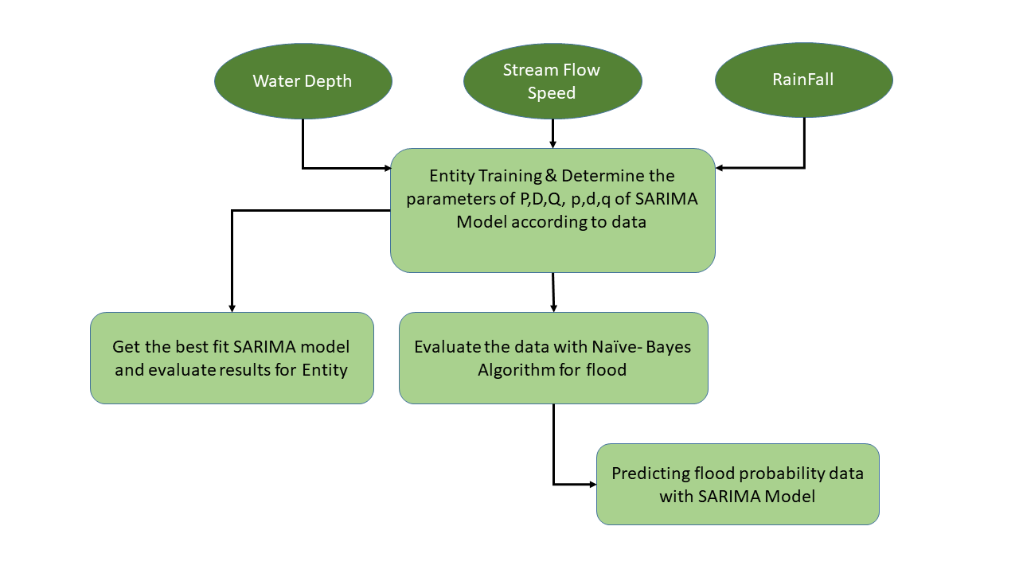

Figure 2.2 Backend Implemntation structure

### **Frontend Implementation**

For frontend implementation, we used Django Framework, which is used for python web framework. It specifically based on HTML, CSS, JavaScript, Ajax, python. SmartGuardian Flood Alerting Admin Web system as follows,

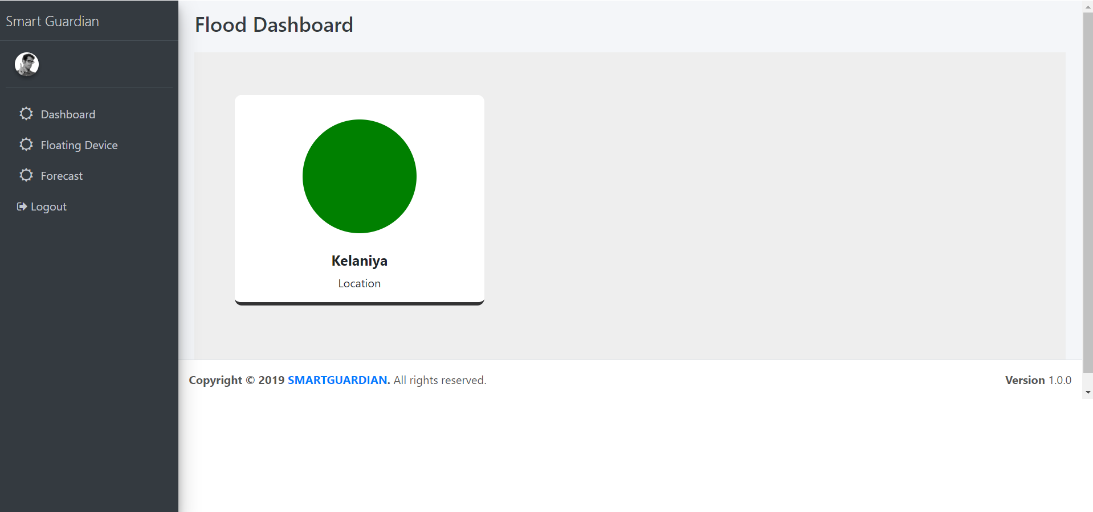

Figure 2.3 FrontEnd Interface 01 - Flood Dashboard

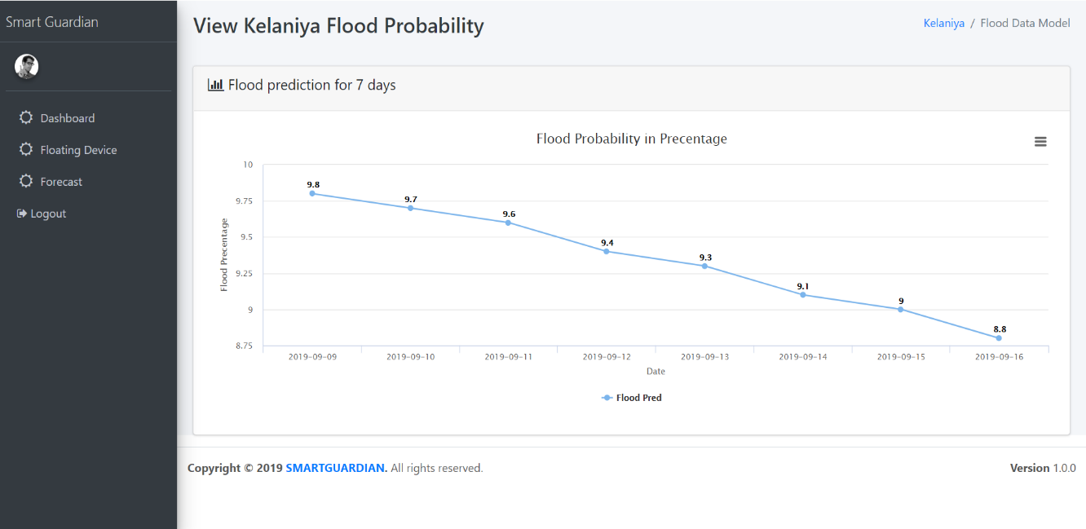

Figure 2.4 Front End Interface 02 - Flood probability results

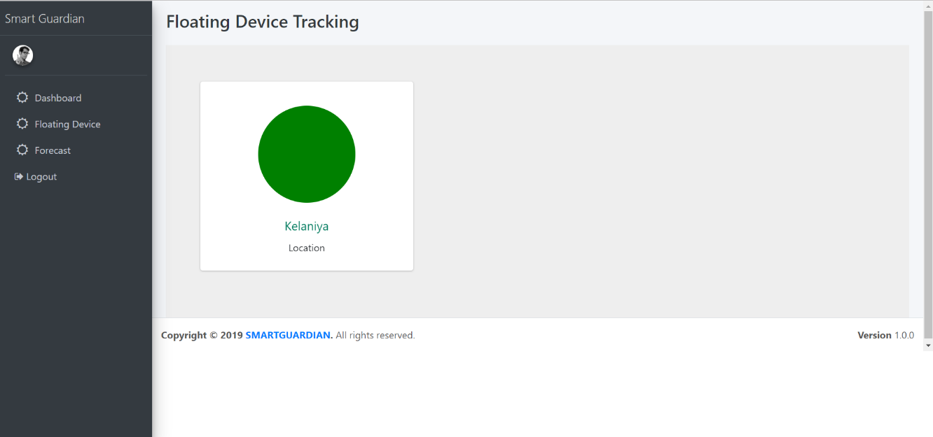

Figure 2.5 Front End Interface 03 - Floating Device Tracing Dashboard

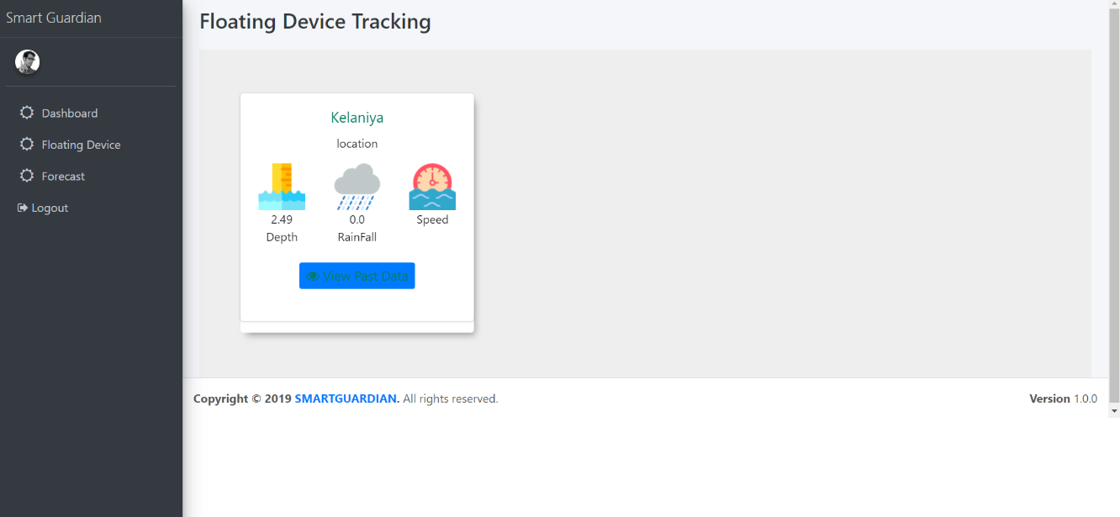

Figure 2.6 Front End Interface 04 - Current data of each attribute comes from floating device

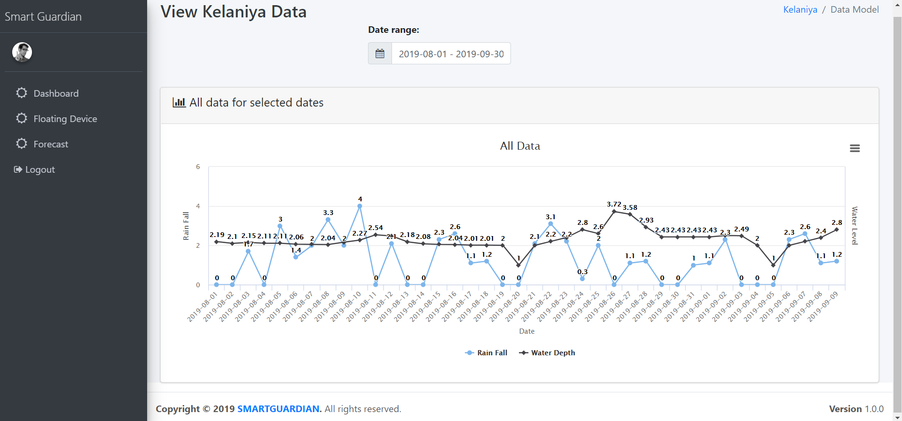

Figure 2.7 Front End Interface 05 - View all factors real data

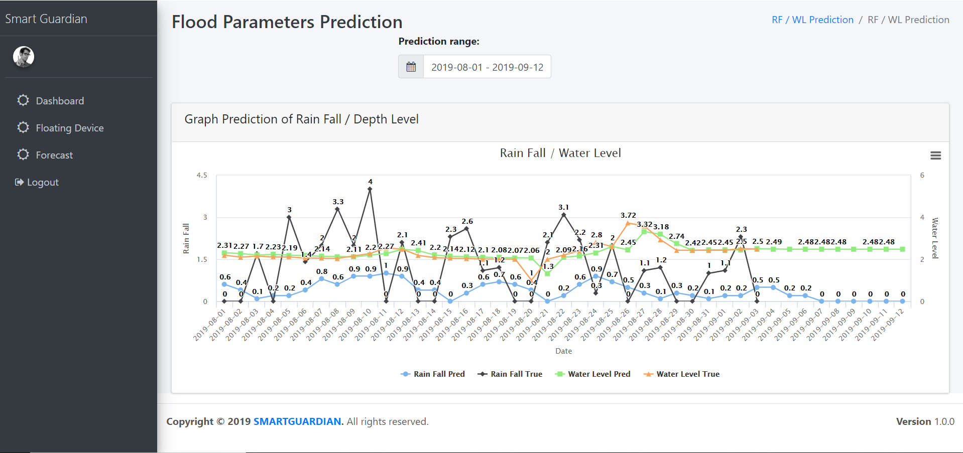

Figure 2.8 Front End Interface 06 - View Predicted Flood factors withe real data

# **RESULT AND DISCUSSION**

## Results

### **Results obtained from SARIMA predictions Algorithms**

Comparison of actual values with relevant predicted values which are obtained from the Seasonal Auto Regressive Integrated Moving Average can be seen from below graphs with respective to the rainfall occurrence to the Kelaniya, Sri Lanka. Testing is done in three different periods to find the optimal result.

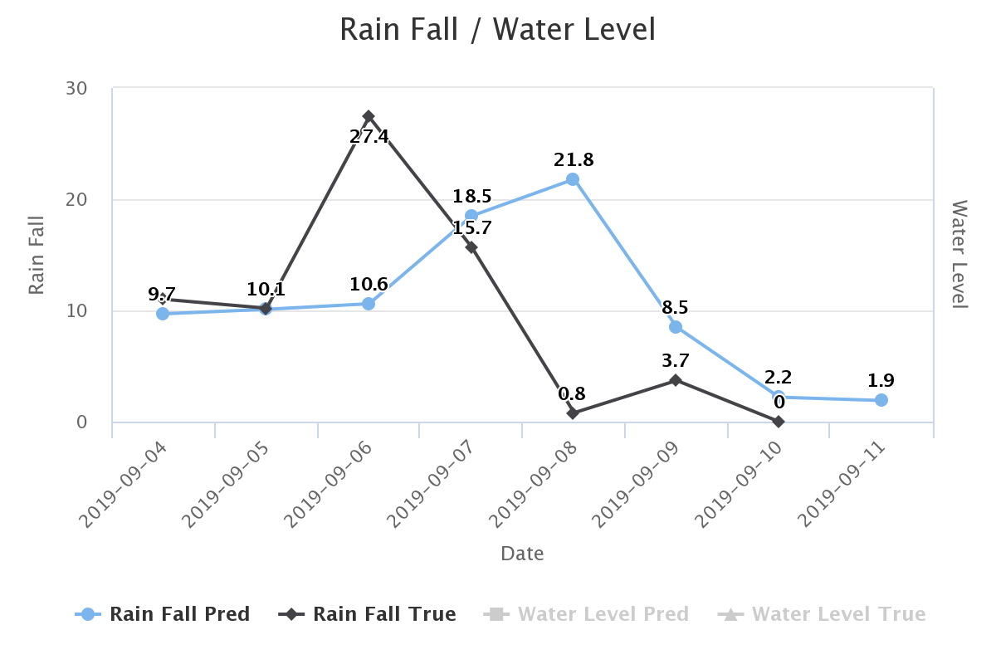

Figure 3.1 RainFall 7 Days Calibration

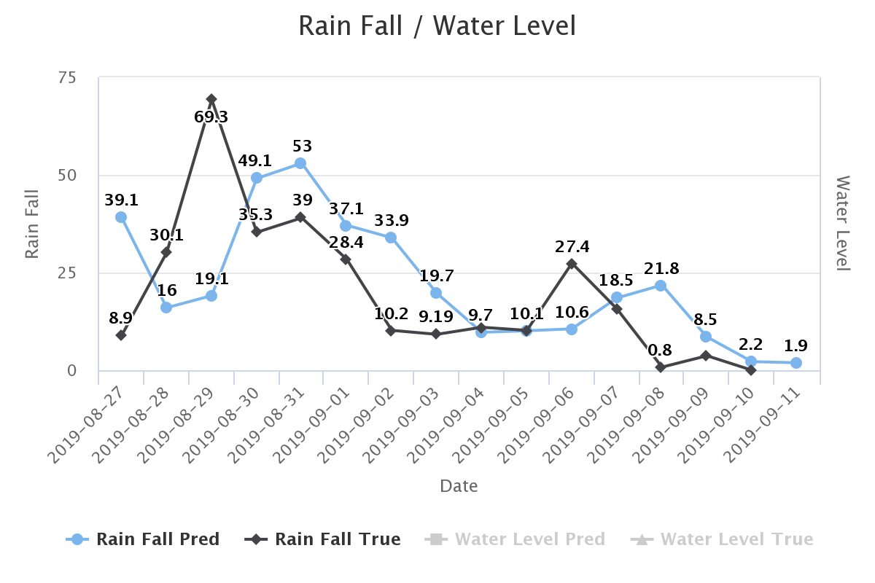

Figure 3.2 RainFall 15 Days Calibration

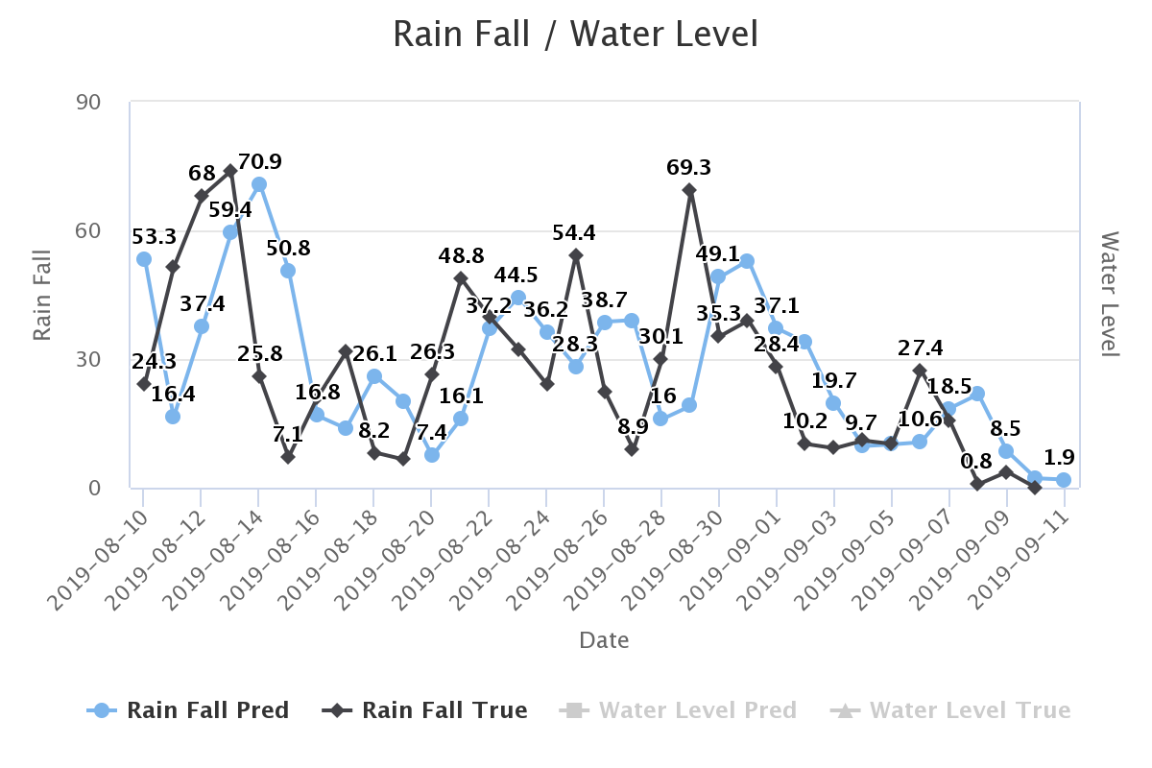

Figure 3.3 RainFall 30 days Calibration

Comparison of actual values with relevant predicted values which are obtained from the SARIMA can be seen from below graphs with respective to the Water Depth occurrence to the Kelaniya, Sri Lanka. Testing is done in three different periods to find the optimal result.

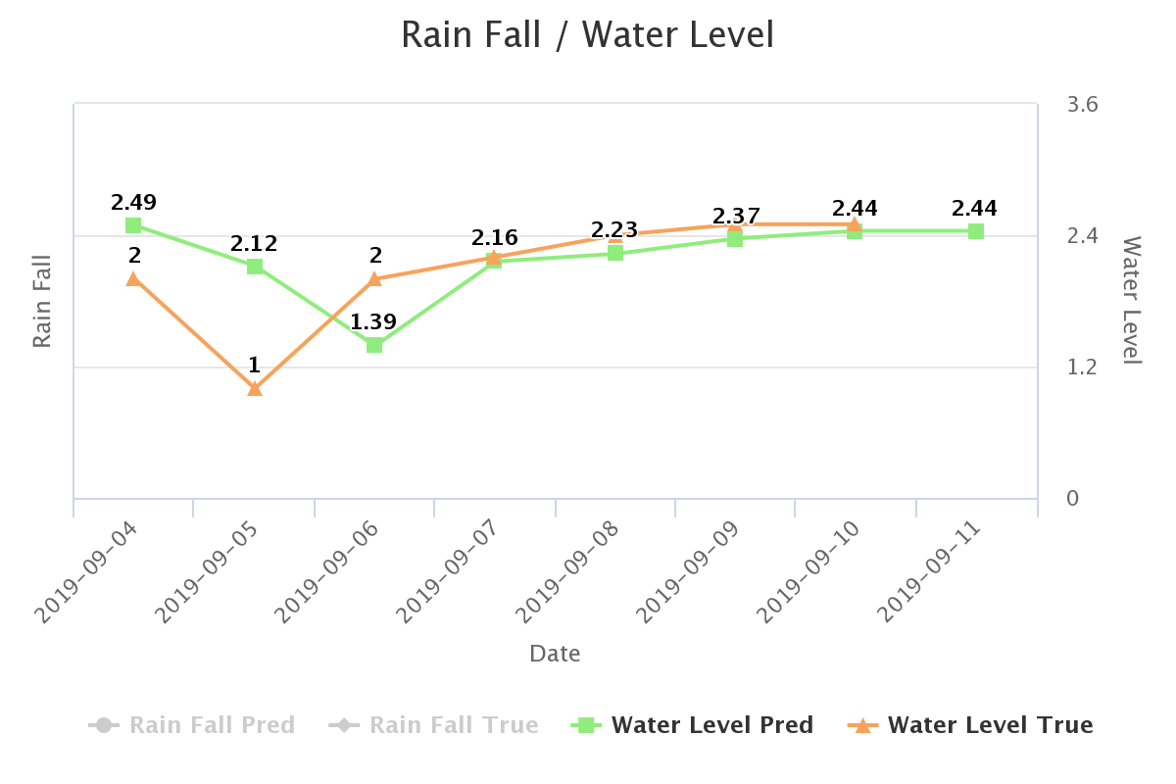Figure 3.4 Water Depth 7 days Calibration

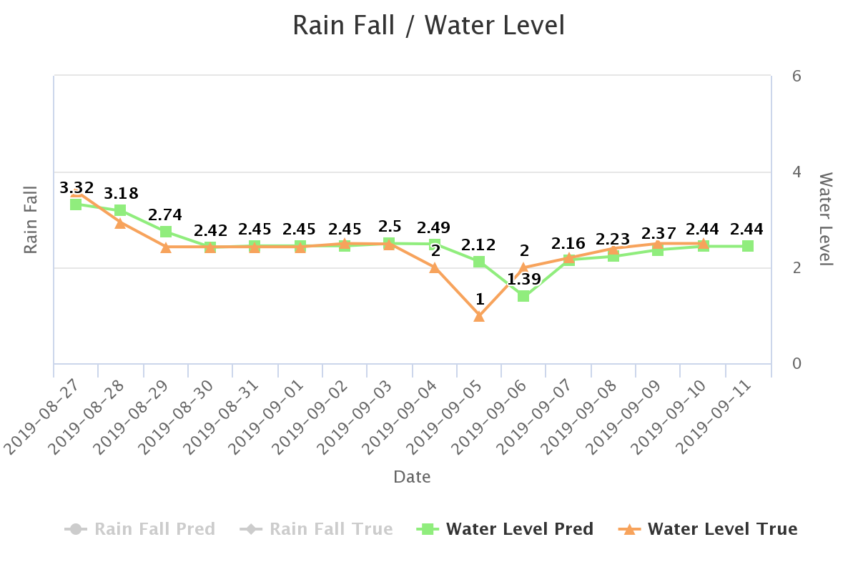Figure 3.5 Water Depth 15 days Calibration

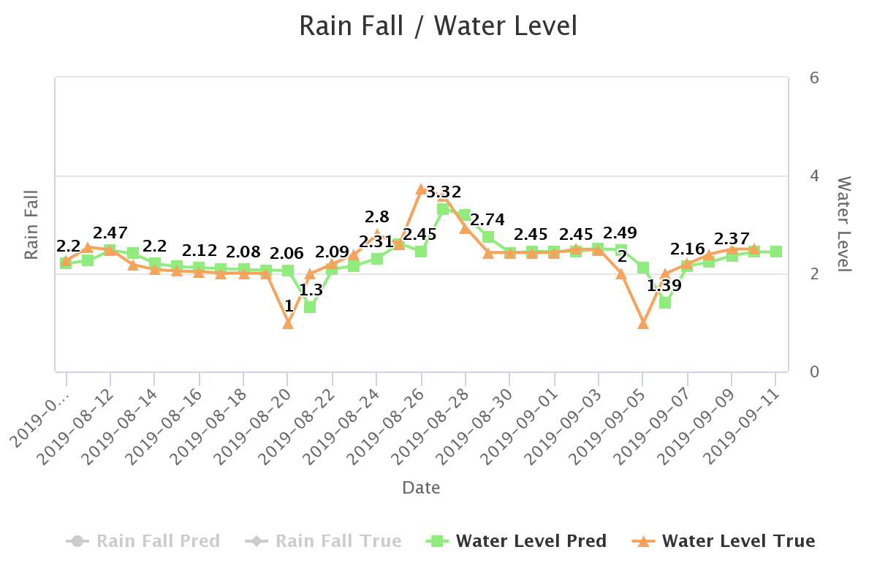Figure 3.6 Water Depth 30 days Calibration

### **Results obtained from Naïve-Bayes & SARIMA Algorithm**

Following is the result of flood prediction by considering above accuracy.

Comparison of actual values with relevant predicted values which are obtained from the SARIMA with above results we were including Naïve- Bayes algorithm for higher accuracy prediction. Algorithm results can be seen from below graphs with respective to the flood occurrence in percentage manner to the Kelaniya, Sri Lanka.

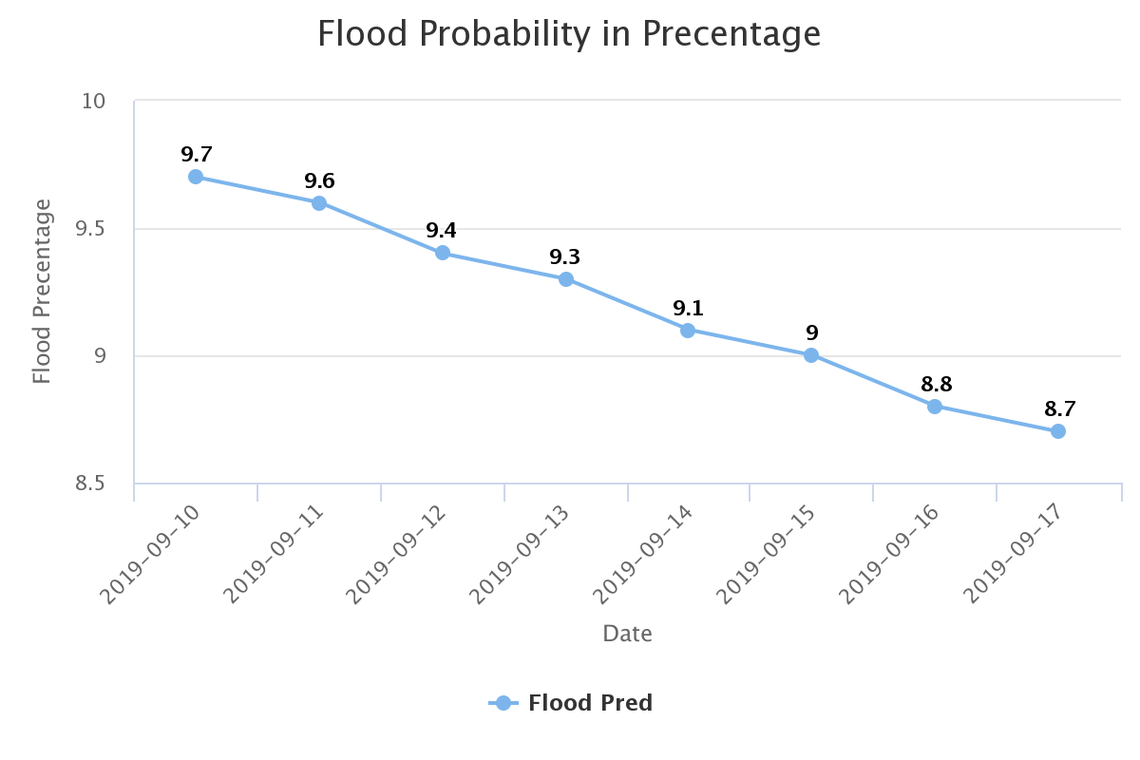Figure 3.7 Flood Prediction results in percentage

## Future Works

As the future works, initially we are planning to conduct more experiments on floating device and try to improve the accuracy of our prediction model. Furthermore, we are planning to expand this product to island wide. In order to gain more economical, benefit from the prediction model.

# **CONCLUSION**

This document based on the flood prediction module of the proposed system for the selected area in Sri Lanka.

The document covers all the information and overview of final product based on research problem, background context, research gap, research question, literature review, methodology and results that relevant to the prediction on flood predictions.

the prediction module was implemented based on Seasonal Auto Regressive Integrated Moving Average and Naïve-Bayes Algorithm with the real data set gathered from Disaster Relief Management Department, Meteorology Department and Irrigation Department of Kelaniya, Sri Lanka and sensor data collected from floating devices.

Every year we can hear minority deaths caused and majority of damage for property due to flood. For the last 3 years flood was being recurred for the Kelaniya area but no one could not able to acknowledge impending situation. To achieve this task we are introducing SmartGuardian Flood Alerting System in trusted manner to survive human lives from flood.

People would be able to assemble themselves and their most valuable property that would be able to take with them by predicting the flood situation. We could not break off flood but we could try to save 65% of human life via this proposed system caused due to flood.

# **REFERENCES**

[1] Mohammed Khalaf, Abir Jaafar Hussain, Dhiya Al-Jumeily, Paul Fergus, Ibrahim Olatunji Idowu , “Advance Flood Detection and Notification System based on Sensor Technology and Machine Learning Algorithm ” DOI: 10.1109/IWSSIP.2015.7314188 , September 2015.

[2] Kirti Bhausaheb Gavali, “SMS Flood Alerting System in Flood Affected Area”, *Department of Electronics and Telecommunication, SVIT College of Enginnering, Chincholi, Nashik, November 2015.*

[3] Matt Beaumont-Gay,” A Comparison of SYN Flood Detection Algorithms” in *International Conference on Internet Monitoring and Protection* , August. 2007, DOI: 10.1109/ICIMP.2007.1

[4] Wahidah Md. Shah , F. Arif , A.A. Shahrin and Aslinda Hassan, “The Implementation of an IoT-Based Flood AlertSystem” Universiti Teknikal Malaysia Melaka, Department of Industrial EngineeringInstitut Teknologi Nasional Bandung, Indonesia , 2018